A

Project Design Report on

" HOME AUTOMATION USING ANDROID PHONE OVER BLUETOOTH "

Submitted by

Mr. Nagane Abhijit Shantaram Mr. Mutkule Abhijeet Kashinath Mr. Kolhe Pranjal Milind

Mr. Pathak Vinayak Vijay

Under The Guidance of DR. V. A. Dhotre

For The Award of The Degree of Bachelor of Engineering



DEPARTMENT OF COMPUTER SCIENCE AND ENGINEERING

SKN SINHGAD COLLEGE OF ENGINEERING

(PUNYASHLOK AHILYADEVI HOLKAR, SOLAPUR UNIVERSITY)

2020-2021

## Abstract

This project revolves around creating a smart home system prototype with the main focus being the ability to lock/unlock a door through the internet. The system consists of a central device, a server and an Android application.

The central device is a microprocessor, in this case, a Raspberry Pi that connects to the Internet and receives an order to control a motor which in turn turns the lock with the help of gears. The ability to rotate the motor in both directions is achieved by the use of an H-bridge. The server manages users and devices, and handles the communication between the application and the central device. Users and devices are stored in a database on the server. The application is a frontend which presents the user with a list of devices to interact with.

The main prototype where the Raspberry Pi acted as a central device was abandoned due to time and resource constraints. It was instead used to control the motor directly. This brought up some problems concerning powering the device using batteries. The software of the prototype is mostly working but due to the same time limitations not all planned features could be implemented.

DEPARTMENT OF COMPUTER SCIENCE AND ENGINEERING

SKN Sinhgad College of Engineering, Korti, Pandharpur.



CERTIFICATE__

This is to certify that, the project design report entitled

"Securing and Managing Patient Data of Rural Healthcare System Through Cloud Environment"

Submitted by

Mr. Abhijit S. Nagane

Mr. Abhijeet K. Mutkule

Mr. Pranjal M. Kolhe

Mr. Vinayak V. Pathak

In the partial full fllment for the award of the Degree of Bachelor of Engineering

This Project design work is a record of student's own work carried out by them under my supervision and guidance during the academic year

2020-2021

Prof. V. A. Dhotre

Project Guide

Prof. N. M. Sawant

Head of Department

|  |  |  |  |  |  |  |
| --- | --- | --- | --- | --- | --- | --- |
| **Chapter No.** | **Particulars** | | | | **Page No.** | |
| **i** | **Declaration** | | | |  | |
| **ii** | **Certificate** | | | |  | |
| **iii** | **Acknowledgment** | | | |  | |
| **iv** | **Abstract** | | | |  | |
| **vi** | **Table of Contents** | | | |  | |
| **vi** | **List of figures** | | | |  | |
| **viii** | **Abbreviations** | | | |  | |
|  | | | | | | |
| **Chapter 1.** | **Overview of Project** | | | |  | |
|  | 1.1 | | Introduction | |  | |
|  | 1.2 | | Block diagram | |  | |
|  | 1.3 | | Project Modules | |  | |
|  | | | | | | |
| **Chapter 2.** | **Hardware Description** | | | | |  |
|  | 2.1 | | | **Microcontroller** | |  |
|  |  | **2.1.1** | | 89552 | |  |
|  |  | **2.1.2** | | Block Diagram | |  |
|  |  | **2.1.3** | | Features | |  |
|  |  | **2.1.4** | | Pin diagram | |  |
|  |  | **2.1.5** | | Pin description | |  |
|  |  | **2.1.6** | | Special Function Registers | |  |
|  |  | **2.1.7** | | Memory Organization | |  |
|  |  | **2.1.7.1** | | Program Memory | |  |
|  |  | **2.1.7.2** | | Data Memory | |  |
|  |  | **2.1.8** | | Watchdog Timer | |  |
|  | **2.2** | | | **BLUETOOTH MODULE (HC-05):Overview** | |  |
|  |  | **2.2.1.** | | Specifications | |  |
|  |  | **2.2.2.** | | Pin out configuration | |  |
|  |  | **2.2.3** | | Typical Application Circuit | |  |
|  |  | **2.2.4.** | | Pairing | |  |
|  |  | **2.2.5.** | | Hc-05 Bluetooth module working voltage | |  |
|  |  | **2.2.6.** | | Serial communication | |  |
|  | **2.3** | | | **Driver IC** | |  |
|  |  | **2.3.1** | | ULN2803A Darlington Transistor Arrays | |  |
|  |  | **2.3.2** | | Simplified Schematics | |  |

|  |  |  |  |  |  |  |
| --- | --- | --- | --- | --- | --- | --- |
|  |  | | **2.3.3.** | | Functional Block Diagram |  |
|  |  | | **2.3.4** | | Pin diagram |  |
|  |  | | **2.3.5** | | Inductive Load Drive |  |
|  |  | | **2.3.6** | | Resistive Load Drive |  |
|  | **2.4** | | | | **Switches** |  |
|  |  | | **2.4.1** | | Relay |  |
|  | **2.5** | | | | **Connector** |  |
|  | **2.6** | | | | **Vp812 burner** |  |
|  | **2.7** | | | | **Power supply** |  |
|  | | | | | | |
| **Chapter 3.** | **Software** | | | | |  |
|  | **Introduction** | | | | |  |
|  | **3.1** | | PROTEUS | | |  |
|  | **3.2** | | KEIL | | |  |
|  | **3.3** | | VP812 | | |  |
|  | **3.4** | | Android App | | |  |
|  | | | | | | |
| **Chapter 4.** | **Serial communication in 89s52** | | | | |  |
|  | **Serial communication-Introduction** | | | | |  |
|  | **4.1** | | | | Selection of baud rate |  |
|  | **4.2** | | | | SBUF register |  |
|  |  | | | **4.2.1** | Configuration of SCON register |  |
|  |  | | | **4.2.2** | SM0, SM1 |  |
|  | **4.3** | | | | **REN (receive enable)** |  |
|  | **4.4** | | | | **TI (transmit interrupt)** |  |
|  | **4.5** | | | | **RI (receive interrupt)** |  |
|  | **4.6** | | | | **Steps for transmitting and receiving of**  **character** |  |
|  |  | **4.6.1** | | | The steps that 8051 goes through in  transmitting a character via TxD |  |
|  |  | **4.6.2.** | | | Programming the 8051 to transfer  character bytes serially |  |
|  |  | **4.6.3** | | | Importance of TI Flag |  |
|  |  | **4.6.4** | | | Programming the 8051 to receive character  bytes serially |  |
|  | | | | | | |
| **Chapter 5.** | **Program** | | | | |  |

|  |  |  |  |  |
| --- | --- | --- | --- | --- |
|  | **5.1** | PROGRAM CODES | |  |
|  | **5.2** | Program detail | |  |
|  | | | |  |
| **Chapter 6.** | **Circuit diagram & Component List** | | |  |
|  | **6.1.** | | Component list |  |
|  | | | | |
| **Chapter 7.** | **Problem descriptions** | | |  |
|  | | | | |
| **Chapter 8.** | **Advantages & Disadvantages** | | |  |
|  | **8.1** | Advantages | |  |
|  | **8.2.** | Disadvantages | |  |
|  | | | | |
| **Chapter 9.** | **Future scope** | | |  |
|  | | | | |
|  | **Conclusion** | | |  |
|  |  | | |  |
|  | **References** | | |  |
|  |  | | |  |
|  |  | | |  |

# List of Figures

|  |  |  |
| --- | --- | --- |
| **Figure No** | **Figure Name** | **Page No.** |
| 1 | Block diagram of Bluetooth based home automation | 3 |
| 2 | Block diagram of 8051 micro controller | 5 |
| 3 | Pin Diagram of 89S52 | 6 |
| 4 | Pull up resistor | 9 |
| 5 | HC-05 Bluetooth | 14 |
| 6 | Pin-out of HC-05 | 15 |
| 7 | Simplified Schematics of ULN2803 | 17 |
| 8 | Functional block diagram of ULN2803 | 18 |
| 9 | Pin diagram of ULN2803 | 19 |
| 10 | Relays | 20 |
| 11 | VP812 hex file burner | 21 |
| 12 | Samsung charger | 22 |
| 13 | Proteus window | 23 |
| 14 | micro vision (keil) | 24 |
| 15 | Window screen of VP912/VP812 burner | 25 |
| 16 | Android Logo | 26 |
| 17 | Selection of baud rate | 28 |
| 18 | SCON register | 29 |
| 19 | Serial mode selection | 30 |
| 20 | Wiring connection to switch | 45 |

**,**

## General Abbreviation

PLC: Programmable logic controllers.

SCADA: Supervisory control and data acquisition. I/P: Input

O/P: Output.

T-On: On timer.

T-Off: Off timer.

M: Memory Bits.

Q: Output in program. MW: Memory words. NO: Normally open. NC: Normally closed.

DCS: Distributed Control System. HMI: Human machine interference. VFD: Variable Frequency Drive.

MD: Memory Double Word.

MB: Memory Byte XIC: Examine If Closed XIO: Examine If Open

# Chapter 1

**OVERVIEW OF PROJECT**

**,**

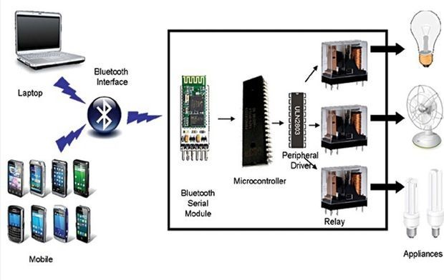

### Chapter 1 OVERVIEW OF PROJECT

* 1. **INTRODUCTION:**

Automation involves introducing a degree of computerized or automatic control to certain electrical and electronic systems in a building. These include lighting, temperature control, etc. The past decade has seen significant advancement in the field of consumer electronics. Various intelligent appliances such as cellular phone, air conditioners, home security devices, home theaters, etc., are set to realize the concept of a smart home. They have given rise to a Personal Area Network in home environment, where all these appliances can be interconnected and monitored using a single controller.

This project demonstrates an automation system which contains a remote mobile host controller and several client modules (eg.Office, home appliances). The client modules communicate with the host controller through a wireless device such as a Bluetooth enabled mobile phone, in this case, an android based Smart phone.

Although automation today is not a new thing but most advanced home automation systems in existence today require a big and expensive change of infrastructure. We have proposed an automation system that can control appliances like TVs, Fan, Tube lights from an android mobile using Bluetooth. In this a low cost secure cell phone based, flexible automation system is introduced. Devices are connected to the microcontroller based switching circuit.

The communication between the cell phone and the microcontroller board is wireless. Additional devices can be connected into the system with little modifications. The phone will be Android OS based phone. The switching circuit will be having microcontroller coding to control the electronics devices like fans and lights etc. 8-bit microcontroller board based on the atmel89s52 and the HC-05 Bluetooth module is used. It supports wireless serial communication over Bluetooth. This board has 32 digital input and output ports.

The 89s52 can be programmed using the microcontroller’s high-level interactive embedded C language. The Bluetooth antenna in our module picks up the packets sent from the cell

phone. Subsequently, these packets containing the device status as commands are pipelined through 89s52 microcontroller and the designed analogue circuitry according to the definition of each output.

Different home or office appliances are connected to the digital output ports of the circuit via relays to provide sufficiently high currents and voltage compatibility. For test purposes, 25W, 240V lamps will be used.

We send commands from an application which is developed in phone to turn ON/OFF a device. A feedback circuit has been designed and implemented to indicate the devices actual status after it receives the command (ON/OFF) from the cell phone. Once the command has been sent to turn ON a device, the feedback circuit senses the current and gives an output signal by turning ON a respective led on the switching circuitry indicating that the device is ON. Otherwise, the device is malfunctioning indicating that the command was not executed successfully. We can also operate the appliances of Home or Office in Bluetooth range area.

**1.1. BlocK DIAGRAM:-**

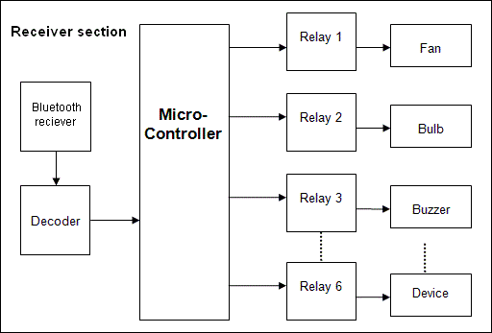

Relay 8

Figure 1: Block diagram of Bluetooth based home automation

In this block diagram communication is in both direction between android mobile and Bluetooth module. This communication is done one by one only one at a time. This communication is called half duplex.

Feedback is done by getting 220v.feedback circuitry is so deigned that microcontroller can easily sense.

### Project Modules :-

The project can be better described by dividing it into two categories, namely,

1. Hardware
2. Software

# Chapter 2

**Hardware Description**

### Chapter 2

### Hardware Description

* 1. **Microcontroller:-**Micro controller is just like a small computer but the basic difference comes in size and memory. These have CPU, RAM, ROM, I/O and timers are all on a single chip. It means you don’t need any extra device to make it functional like with a

micro-processor. Generally this microcontroller is used where a specific task is needed to do. So fixed amount of on-chip ROM, RAM, and number of I/O ports makes them ideal for a many applications in which cost and space are critical The microcontroller is used by us in over project is AT89S52.

**2.1.1.89S52:-** The AT89S52 is a low-power, high-performance CMOS 8-bit microcontroller with 8K bytes of in-system programmable Flash memory. The device is manufactured using Atmel’s high-density nonvolatile memory technology and is compatible with the industry-standard 80C51 instruction set and pin out. The on-chip Flash allows the

program memory to be reprogrammed in-system or by a conventional nonvolatile memory programmer. By combining a versatile 8-bit CPU with in-system programmable Flash on a monolithic chip, the Atmel AT89S52 is a powerful microcontroller which provides a highly- flexible and cost-effective solution to many embedded control applications. The AT89S52 provides the following standard features: 8K bytes of Flash, 256 bytes of RAM, 32 I/O lines, Watchdog timer, two data pointers, three 16-bit timer/counters, a six-vector two-level interrupt architecture, a full duplex serial port, on-chip oscillator, and clock circuitry. In addition, the AT89S52 is designed with static logic for operation down to zero frequency and supports two software selectable power saving modes. The Idle Mode stops the CPU while allowing the RAM, timer/counters, serial port, and interrupt system to continue functioning. The Power-down mode saves the RAM con-tents but freezes the oscillator, disabling all other chip functions until the next interrupt or hardware reset. The block diagram is shown below.

### Block Diagram:-

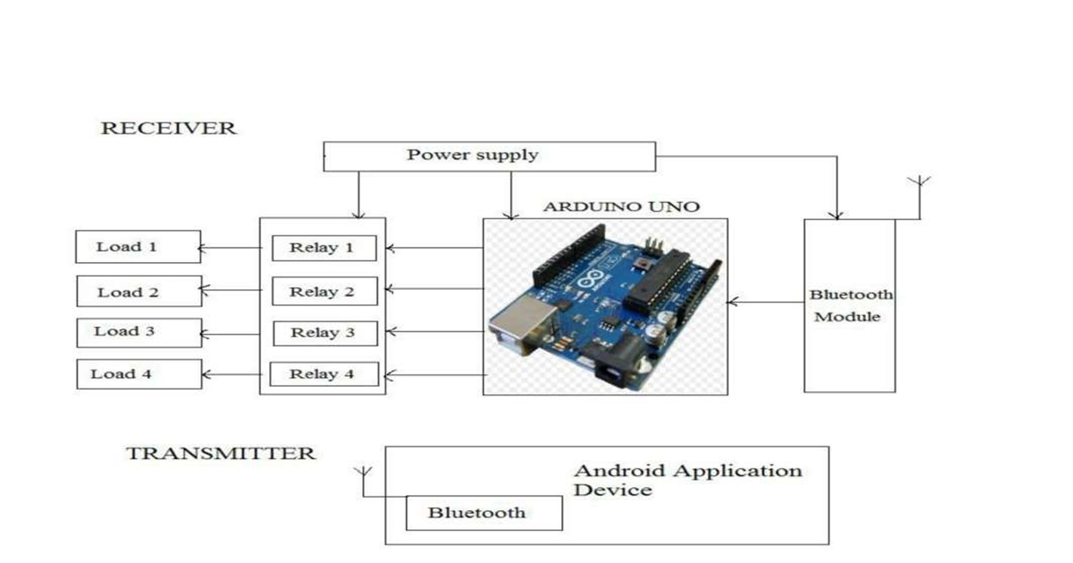

Figure 2: Block diagram of 8051 micro controller

* + 1. **Features**
       1. Compatible with MCS®-51 Products
       2. 8K Bytes of In-System Programmable (ISP) Flash Memory

– Endurance: 10 k Write/Erase Cycles

* + - 1. 4.0V to 5.5V Operating Range
      2. Fully Static Operation: 0 Hz to 33 MHz
      3. Three-level Program Memory Lock
      4. 256 x 8-bit Internal RAM
      5. 32 Programmable I/O Lines
      6. Three 16-bit Timer/Counters
      7. Eight Interrupt Sources
      8. Full Duplex UART Serial Channel
      9. Low-power Idle and Power-down Modes
      10. Interrupt Recovery from Power-down Mode
      11. Watchdog Timer
      12. Dual Data Pointer
      13. Power-off Flag
      14. Fast Programming Time
      15. Flexible ISP Programming (Byte and Page Mode)
      16. Green (Pb/Halide-free) Packaging Option

### 2.1.4 Pin diagram:-

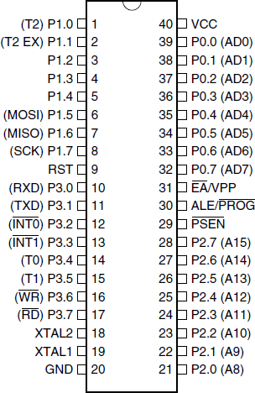

Fig. 3: Pin Diagram of 89S52

### Pin description:- VCC:

Pin 40 provides supply voltage to the chip. The voltage source is +5 Volts.

### GND:

Pin 20 is the ground.

### XTAL1 and XTAL2:

The 8051 has an on chip oscillator but requires an external clock to run it. Most often a quartz crystal oscillator is connected to inputs XTAL1 (pin 19) and XTAL2 (pin 18). The quartz crystal oscillator connected to XTAL1 and XTAL2 also needs two capacitors of 30 pf value. One side of each capacitor is connected to the ground. Speed refers to the maximum oscillator frequency connected to XTAL .When the 8051 is connected to a crystal oscillator is powered up we can observe the frequency on the XTAL2 pin using the oscilloscope.

### RST:

Pin 9 is the RESET pin. It is an input and is active high. Upon applying a high pulse to this pin the microcontroller well reset and terminate all activities. This is often referred to as a power on reset .Activating a power on reset will cause all values the registers to be lost. It will set program counter to all 0s.

In order for the RESET input to be effective it must have a minimum duration of two machine cycles. In other words the high pulse must be high for a minimum of two machine cycles before it is allowed to go low.

### EA:

The 8051 family members such as the 8751/52, 89C51/52 or DS89C4*0 all come with on chip ROM to store programs. In such cases the EA pin is connected to Vcc. For family members such as the 8031 and 8032 in which there is no on chip ROM, code is stored on an external ROM and is fetched by 8031/32. Therefore for the 8031 the EA pin must be connected to

GND to indicate that the code is stored externally. EA which stands for “external access” is pin number 31 in the DIP packages. It is an input pin and must be connected to either Vcc or GND. In other words it cannot be unconnected.

### PSEN:

This is an output pin. PSEN stands for “program store enable”. In an 8031 based system in which an external ROM holds the program code, this pin is connected to the OE pin of the ROM.

### ALE:

ALE stands for “address latch enable. It is an output pin and is active high. When connecting an 8031 to external memory, port 0 provides both address and data. In other words the 8031 multiplexes address and data through port 0 to save pins. The ALE pin is used for de- multiplexing the address and data by connecting to G pin of the 74LS373 chip.

### PORTS 0,1,2,3:

All the ports upon RESET are configured as input, since P0-P3 have value FFH on them. The following is a summary of features of P0-P3.

### PORT 0:

Port 0 is also designated as AD0-AD7 allowing it to be used for both address and data. When connecting an 8051/31 to an external memory, port 0 provides both address and data. The 8051 multiplexes address and data through port 0 to save pins. ALE indicates if p0 has address A0-A7.in the 8051 based systems where there is no external memory connection the pins of P0 must be connected externally to 10k-ohm pull-up resistor. This is due to the fact that P0 is an open drain, unlike P1, P2 and P3. Open drain is a term used for MOS chips in the same way that open collector is used for TTL chips. In many systems using the 8751, 89c51 or DS89c4*0 chips we normally connect P0 to pull up resistors.

Port 0 also receives the code bytes during Flash programming and outputs the code bytes

during program verification. External pull-ups are required during program verification.

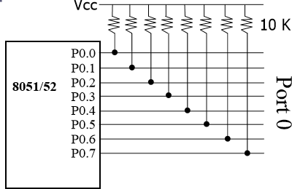

Fig. 4.pull up resistor

**Port 1:**

Port 1 is an 8-bit bidirectional I/O port with internal pull-ups. The Port 1 output buffers can sink/source four TTL inputs. When 1s are written to Port 1 pins, they are pulled high by the internal pull-ups and can be used as inputs. As inputs, Port 1 pins that are externally being pulled low will source current (IIL) because of the internal pull-ups. In addition, P1.0 and P1.1 can be configured to be the timer/counter 2 external count input (P1.0/T2) and the timer/counter 2 trigger input (P1.1/T2EX), respectively, as shown in the following table. Port 1 also receives the low-order address bytes during Flash programming and verification.

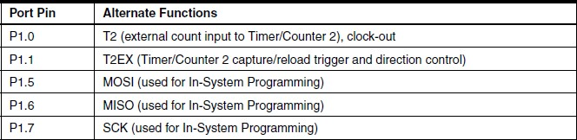

### Port 2

Port 2 is an 8-bit bidirectional I/O port with internal pull-ups. The Port 2 output buffers can sink/source four TTL inputs. When 1s are written to Port 2 pins, they are pulled high by the internal pull-ups and can be used as inputs. As inputs, Port 2 pins that are externally being pulled low will source current (IIL) because of the internal pull-ups. Port 2 emits the high- order address byte during fetches from external program memory and during accesses to external data memory that uses 16-bit addresses (MOVX @ DPTR). In this application, Port 2 uses strong internal pull-ups when emitting 1s. During accesses to external data memory that uses 8-bit addresses (MOVX @ RI), Port 2 emits the contents of the P2 Special Function Register. Port 2 also receives the high-order address bits and some control signals during Flash programming and verification.

### Port 3

Port 3 is an 8-bit bidirectional I/O port with internal pull-ups. The Port 3 output buffers can sink/source four TTL inputs. When 1s are written to Port 3 pins, they are pulled high by the internal pull-ups and can be used as inputs. As inputs, Port 3 pins that are externally being pulled low will source current (IIL) because of the pull-ups. Port 3 receives some control signals for Flash programming and verification. Port 3 also serves the functions of various special features of the AT89S52, as shown in the following table.

### Port 3 Alternate functions:

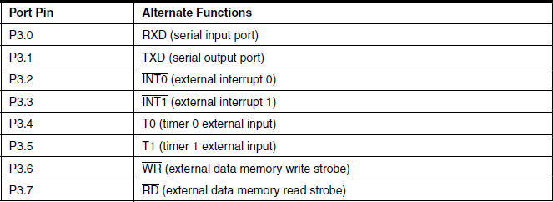

* + 1. **Special Function Registers:**

**Timer 2 Registers:** Control and status bits are contained in registers T2CON (shown in Table 5- 2) and T2MOD (shown in Table 10-2) for Timer 2. The register pair (RCAP2H, RCAP2L) is the Capture/Reload registers for Timer 2 in 16-bit capture mode or 16-bit auto-reload mode.

**Interrupt Registers:** The individual interrupt enable bits are in the IE register. Two priorities can be set for each of the six interrupt sources in the IP register.

**Dual Data Pointer Registers:** To facilitate accessing both internal and external data memory, two banks of 16-bit Data Pointer Registers are provided: DP0 at SFR address locations 82H- 83H and DP1 at 84H-85H. Bit DPS = 0 in SFR AUXR1 selects DP0 and DPS = 1 selects DP1. The user should ALWAYS initialize the DPS bit to the appropriate value before accessing the respective Data Pointer Register.

**Power off Flag:** The Power Off Flag (POF) is located at bit 4 (PCON.4) in the PCON SFR. POF is set to “1” during power up. It can be set and rest under software control and is not affected by reset.

### Memory Organization

MCS-51 devices have a separate address space for Program and Data Memory. Up to 64K bytes each of external Program and Data Memory can be addressed.

* + - 1. **Program Memory**

If the EA pin is connected to GND, all program fetches are directed to external memory. On the AT89S52, if EA is connected to VCC, program fetches to addresses 0000H through 1FFFH are directed to internal memory and fetches to addresses 2000H through FFFFH are to external memory.

* + - 1. **Data Memory**

The AT89S52 implements 256 bytes of on-chip RAM. The upper 128 bytes occupy a parallel address space to the Special Function Registers. This means that the upper 128 bytes have the same addresses as the SFR space but are physically separate from SFR space.

When an instruction accesses an internal location above address 7FH, the address mode used in the instruction specifies whether the CPU accesses the upper 128 bytes of RAM or the SFR space. Instructions which use direct addressing access the SFR space.

For example, the following direct addressing instruction accesses the SFR at location 0A0H (which is P2).

**MOV 0A0H, #data**

Instructions that use indirect addressing access the upper 128 bytes of RAM. For example, the following indirect addressing instruction, where R0 contains 0A0H, accesses the data byte at address 0A0H, rather than P2 (whose address is 0A0H).

**MOV @R0, #data**

Note that stack operations are examples of indirect addressing, so the upper 128 bytes of data RAM are available as stack space.

### Watchdog Timer (One-time Enabled with Reset-out)

The WDT is intended as a recovery method in situations where the CPU may be subjected to software upsets. The WDT consists of a 14-bit counter and the Watchdog Timer Reset (WDTRST) SFR. The WDT is defaulted to disable from exiting reset. To enable the WDT, a user must write 01EH and 0E1H in sequence to the WDTRST register (SFR location 0A6H). When the WDT is enabled, it will increment every machine cycle while the oscillator is running. The WDT timeout period is dependent on the external clock frequency. There is no way to disable the WDT except through reset (either hardware reset or WDT overflow reset). When WDT over-flows, it will drive an output RESET HIGH pulse at the RST pin.

### BLUETOOTH MODULE (HC- 05):

**Overview:** Communication device:-over project is based on wireless communication between micro controller and mobile phone. But alone micro controller is not able to communicate directly to the android mobile phone. Bluetooth Serial module’s operation

doesn’t need drive, and can communicate with the other Bluetooth device that has the serial. But communication between two Bluetooth modules requires at

Least two conditions:

1. The communication must be between master and slave.
2. The password must be correct.

HC-05 module is an easy to use Bluetooth SPP (Serial Port Protocol) module, designed for transparent wireless serial connection setup. Serial port Bluetooth module is fully qualified Bluetooth V2.0+EDR (Enhanced Data Rate) 3Mbps Modulation with complete 2.4GHz radio transceiver and baseband. It uses CSR Blue core 04-External single chip Bluetooth system with CMOS technology and with AFH (Adaptive Frequency Hopping Feature). It has the

Foot print as small as 12.7mmx27mm.

HC-05 module is an easy to use Bluetooth SPP (Serial Port Protocol) module, designed for transparent wireless serial connection setup. Serial port Bluetooth module is fully qualified Bluetooth V2.0+EDR (Enhanced Data Rate) 3Mbps Modulation with complete 2.4GHz radio transceiver and baseband

Bluetooth Wireless networks for short range communications have a wide spread usage of Bluetooth radio transmissions between 2400–2480 MHz Modern mobile devices embed small, low-powered and cheap integrated chips functioning as short-range radio transceivers for Bluetooth radio communications. Device pairing, authentication, encryption and authorization techniques have given recognition to Bluetooth technology due to its vital security mechanisms.

Different types of Bluetooth applications can be developed using Android platform architecture using the Bluetooth profiles. The device manufacturers provide the services using the support of these profiles in their devices to maintain compatibility for the Bluetooth technology

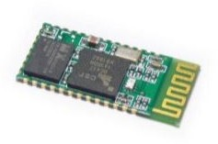

Fig. 5.HC-05 Bluetooth

* + 1. **Specifications**

**Hardware features**

* + - * Typical -80dBm sensitivity.
      * Up to +4dBm RF transmits power.
      * Low Power 1.8V Operation, 3.3 to 5 V I/O.
      * PIO control.
      * UART interface with programmable baud rate.
      * With integrated antenna.
      * With edge connector.

### Software features

* Slave default Baud rate: 9600, Data bits:8, Stop bit:1,Parity:No parity.
* PIO9 and PIO8 can be connected to red and blue led separately. When master and slave are paired, red and blue led blinks 1time/2s in interval, while disconnected only blue led blinks 2times/s.
* Auto connects to the last device on power as default.
* Permit pairing device to connect as default.
* Auto pairing PINCODE:”1234” as default.
* Auto reconnect in 30 min when disconnected as a result of beyond the range of connection.

### Pin out configuration

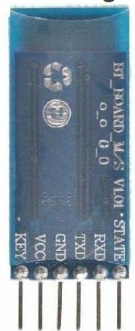

Figure 6: Pin-out of HC-05

* + 1. **Typical Application Circuit:**

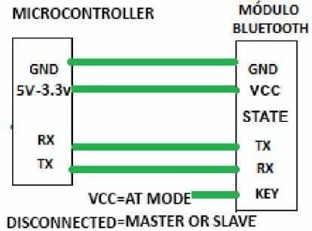

* + 1. **Pairing:**

After connect the Bluetooth module, scan for new devices from the Android phone and you will find the module with the device name “HC-05”, after that, click to connect, if some message appears asking about “Pairing code” just put

**“1234”** as default code.

BLUE LED = ACTIVE (Blinking 500ms period inactive connection, change 1seg with active connection)

### How to get to the standard communication mode

1. Leave free KEY, don’t connect it to VDD neither GND.
2. Supply power to the module. Then the module will enter to communication mode. It can be used for pairing.

### HC-05 BLUETOOTH MODULE WORKING VOLTAGE:-

The Bluetooth module HC-05 is used to receive & transmit data between Bluetooth device and MCU. It requires power supply from 3.3V to 5V.

### SERIAL COMMUNICATION:-

To transfer to a device located many meters away, the serial method is used. The data is sent one bit at a time. Here not 8bit data is send 2 extra bit are send along with it .this two bit are called start bit and stop bit. These tow bit are used so synchronization can be done between transmitter and receiver.

### Driver IC:

#### ULN2803A Darlington Transistor Arrays:-

The ULN2803A device is a high-voltage, high- current Darlington transistor array. The device consists of eight NPN Darlington pairs that feature high-voltage outputs with common-cathode clamp diodes for switching inductive loads. The collector-current rating of each Darlington pair is 500 mA. The Darlington pairs may be connected in parallel for higher current capability.

#### Simplified Schematics

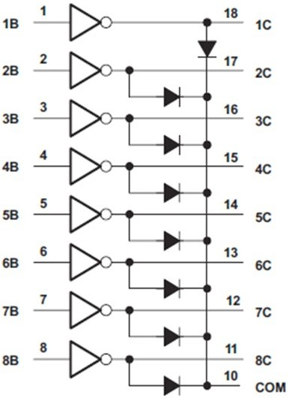

Fig. 7.Simplified Schematics of ULN2803

**2.3.3. Functional Block Diagram:**

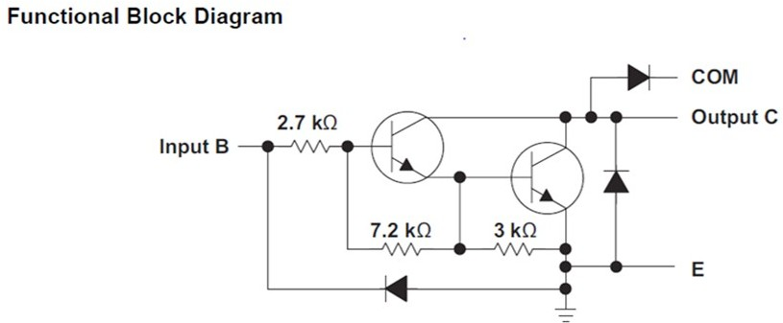

Fig. 8.Functional block diagram of ULN2803

Each channel of ULN2803A consists of Darlington connected NPN transistors. This connection creates the effect of a single transistor with a very high current gain. This can be as high as 10,000 A/A at certain currents. The very high gain allows for high output current drive with a very low input current, essentially equating to operation with low GPIO voltages. The GPIO voltage is converted to base current via the 2.7 kΩ resistor connected between the input and base of the pre-driver Darlington NPN. The 7.2 kΩ & 3.0 kΩ resistors connected between the base and emitter of each respective NPN act as pull-downs and suppress the amount of leakage that may occur from the input. The diodes connected between the output and COM pin is used to suppress the kick-back voltage from an inductive load that is excited when the NPN drivers are turned off (stop sinking) and the stored energy in the coils causes a reverse current to flow into the coil supply via the kick-back diode. In normal operation the diodes on base and collector pins to emitter will be reversed biased. If these diode are forward biased, internal parasitic NPN transistors will draw (a nearly equal) current from other (nearby) device pins.

#### Pin diagram:-

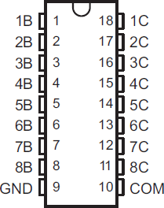

Fig. 9.pin diaygram of uln 2803

ULN2803A Darlington Transistor Arrays pin no 10 can be used for inductive or non-inductive load. These high output current driver pin can sink 500mA.If requirement of more current then two pin can also be connected parallel. Parallel connection must be done both input and output. Input and output current will multiply according to number of input and output connected parallel.

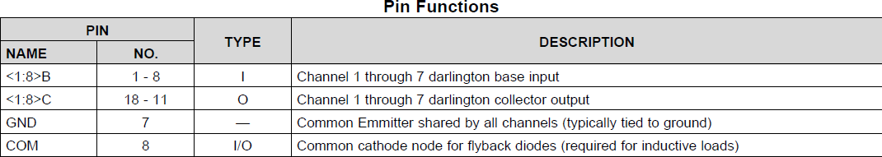

#### Inductive Load Drive

When the COM pin is tied to the coil supply voltage, ULN2803A is able to drive inductive loads and suppress the Kick-back voltage via the internal freewheeling diodes.

#### Resistive Load Drive

When driving a resistive load, a pull-up resistor is needed in order for ULN2803A to sink current and for there to be a logic high level. The COM pin can be left floating for these applications

### Switches:-

Switches are used for connecting or disconnecting electrical circuit. Many types of switches are there. Some are operate mechanically or electrically. Some types are SPST, SPDT, DPST and DPDT in case of switch. SPST stands for single pole single through, SPDT stands for single pole double through, DPST stands for double pole single through and DPDT stands for double pole double through,

In relays points are defines by NO, NC. NO stand for normally on and NC stands for normally off.

#### 2.4.1 Relay:-

Relays are electromagnetic switch. Which can be turn on and off by Appling electrical current. Working voltage is printed on the relay. In this project we are using 6volt relay. Many relay use an electromagnet to mechanically operate a switch.

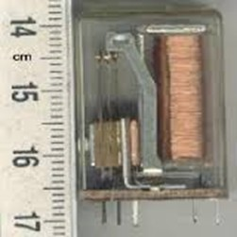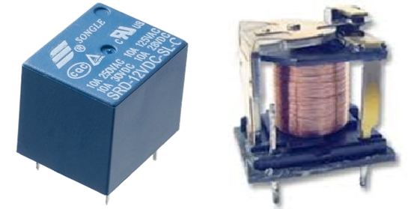

Fig.10. .Relays

* 1. **Connector:-**

Connectors are used for joining two wires temporally by using connector big circuit can be divided and after completion they can rejoin. Now a day’s every time inverter circuited can be removed out without using de soldering.

### Vp812 burner:-

This is the vp812 burner hardware. This is used to burn hex file to the ATMEL 89s52 microcontroller. This burner we can also burn PIC, AVR microcontrollers.

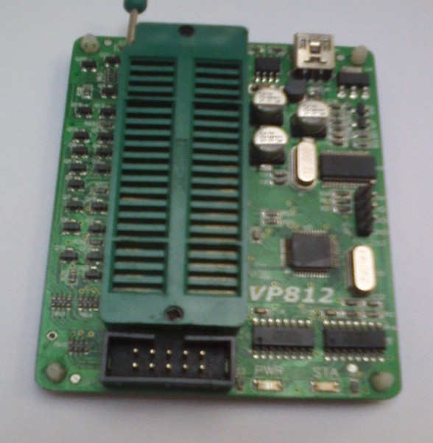

Figure 11: VP812 hex file burner

There is a method given which shows how to place microcontroller on this burner. If wrong method is used then there will be error display “id not matched”. This vp812 burner comes with support cd which has software. This cd includes usb to serial software.

This software support window 7, vista and XP only.

### Power supply:-

Samsung charger is used for giving 5v power supply to the circuit. This charger having power of 700 mA. So circuit can run properly. This Samsung charger is made of switch mode power supply.

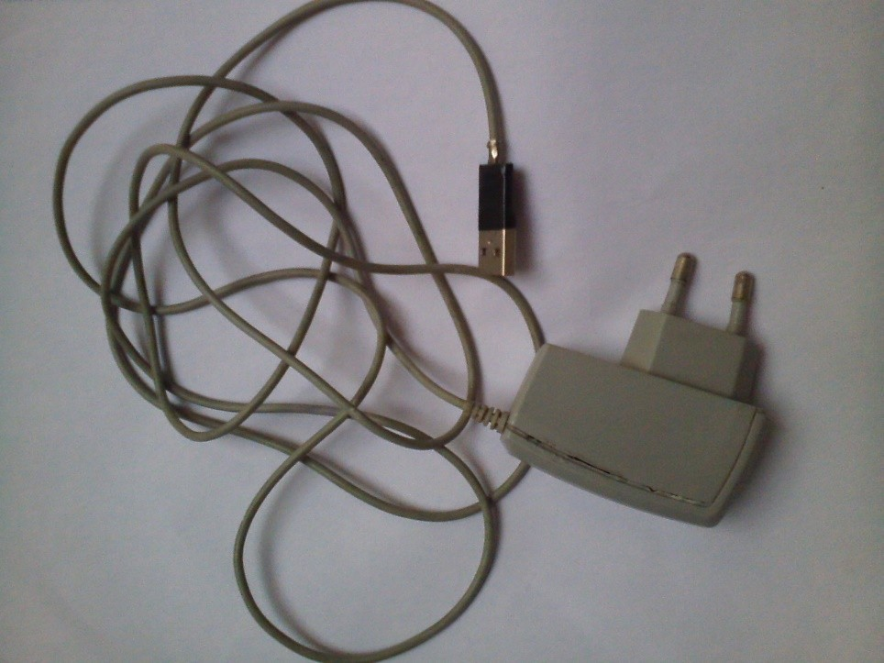

Fig. 12.Samsung charger

In many project this can be very useful because of compact package. If we made a normally power supply by using transformer then it takes larger space on voltage regulation must be done. But in this charger all thing is done. As this charger is used for charging the battery so it can gave continues fixed voltage for long time of period. This charger circuitry is made by semiconductor and a small transformer or we can say SMPS “switch mode power supply” as a capacitor is used in this charger so charger can gave output for a short duration if power is switched-off.

# Chapter 3 Software



### Chapter 3

**Software**

**INTRODUCTION:** Electronic design automation (EDA or ECAD) is a category of software tools for designing electronic systems such as printed circuit boards and integrated circuits. The tools work together in a design flow that chip designers use to design and analyze entire semiconductor chips. The various software’s used are:

### PROTEUS:-

Proteus is software in which we can design the circuit with using hard ware component. In this software input and output relation is shows in this software.

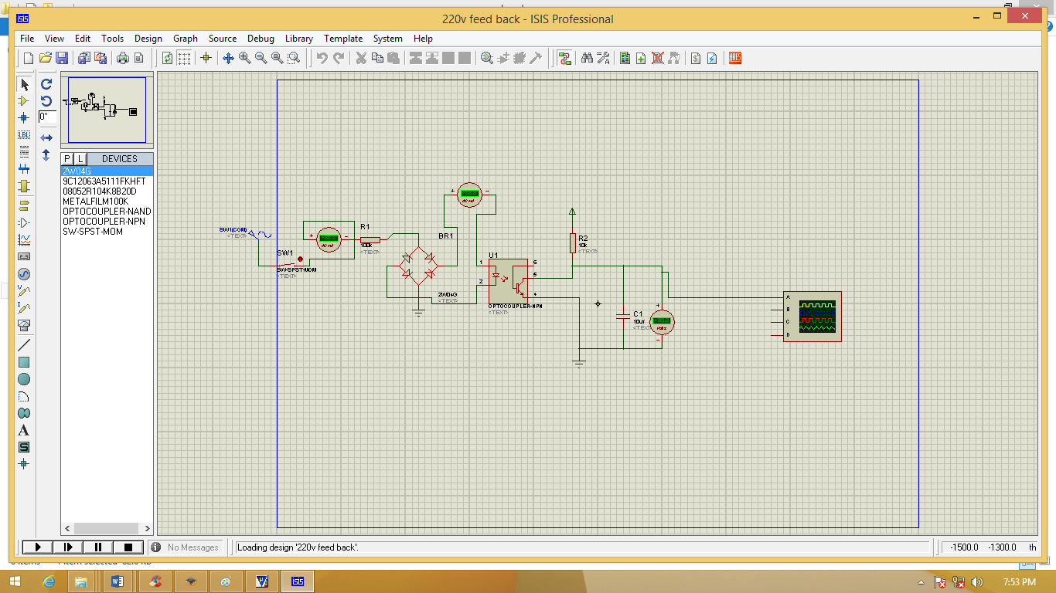

Fig. 13.Proteus window

Proteus is a high-performance simulator for MIMD multiprocessors. It is fast, accurate, and flexible. It is one to two orders of magnitude faster than comparable simulators, it can reproduce results from real multiprocessors, and it is easily configured to simulate a wide range of architectures.

Proteus provides a modular structure that simplifies customization and independent replacement of parts of architecture. Various type of circuit can be made in this circuit can be analogies or digital. Hear many testing device are presented in this like ammeter, voltmeter, oscilloscope etc.

### KEIL:-

Keil software is used to convert c language program to hex file format which can easily bun in micro controller.

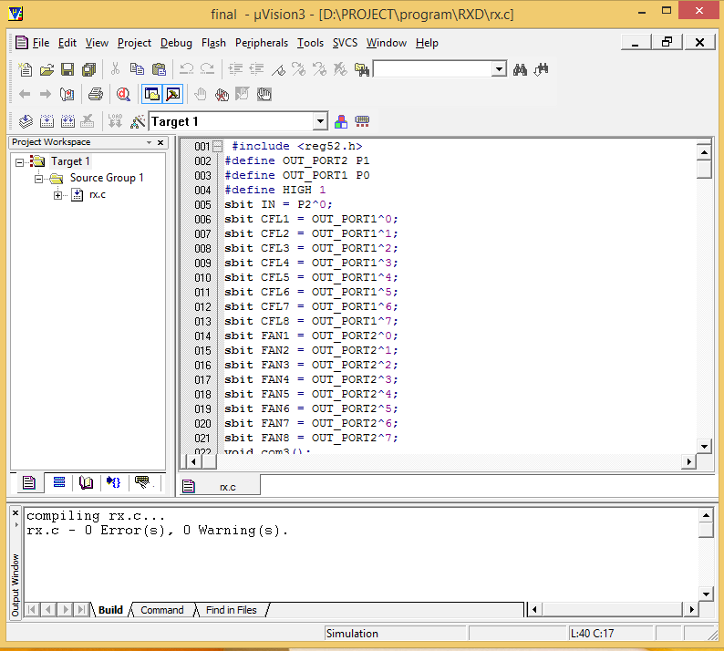

Fig. 14.micro vision (keil)

**Step to make a new program:-**

1. Click on project on status bar and select new project.
2. Give a name to project.
3. Select new file in file on status bar.
4. Press control + s and give file name with extension name .c.
5. Press “option for target “look as magic stick present on target 1.
6. Write crystal frequency in MHz
7. Select output and click on create hex file.

The created hex file will found in installation drive of keil.

### 3.3 VP812:-

**Features:**

* + Supports ATMEL series MCU **( 8051 and AVR )**
  + Support Win bond new 8051 MCU, such as W78E052D/054D/058D/516D.
  + Support Sync MOS MCU.
  + Support STC series MCU.
  + Support PIC series MCU.
  + Support AVR series MCU from ISP downloading and some AVR MCU with high voltage programming.
  + Support 25 series EEPROM/FLASH.
  + Support NXP (Philips) 8051 MCU
  + Support common used 29 series Parallel EEPROM 32 pins.
  + Support common used 39 series Parallel EEPROM 32 pins.
  + Support common used 49 series Parallel EEPROM 32 pins.
  + Support TTL flash boot loader.
  + Use high quality 40 pins IC locker holder.
  + USB communication supports WinXP /Vista/Win7（32/64 bits) System.
  + Support firmware updates.
  + Supports circuit protection.

The window of vp812 is shown below figure

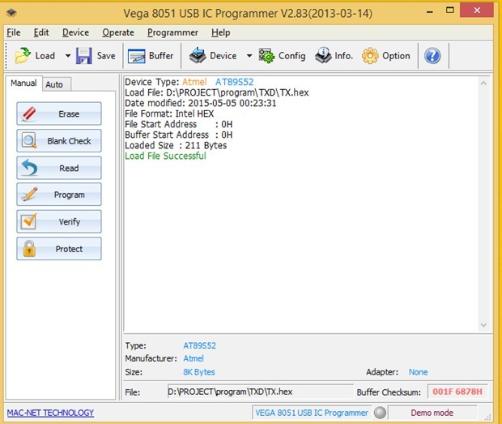

Figure 15: Window screen of VP912/VP812 burner

**Steps for burning hex files:-**

1. First select device.
2. Check how to place microcontroller.
3. Load hex file from folder.
4. Select auto mode in left side.

If hex file burn then task will be complete. If not device id error comes then clean micro controller pin and replaces it and restart from step first.

### 3.4 Android App:-



Figure 16: Android Logo

Android has a dictionary meaning of being a human that resembles automation. The true character of its name is it’s the Google created software stack for creating comprehensive Mobile Applications and Software to realize the full potential of one’s Mobile handset and its possibilities.

Android is a comprehensive software stack of mobile devices that includes an operating system, middleware and key application. This rich source of software bunch is used in Mobile Technology through its innovation module of The Android Software Development Kit (SDK).

**Applications:**

These are the basics of Android applications:

* Android applications are composed of one or more application components (activities, services, content providers, and broadcast receivers)
* Each component performs a different role in the overall application behavior, and each one can be activated individually (even by other applications)
* The manifest file must declare all components in the application and should also declare all application requirements, such as the minimum version of Android required and any hardware configurations required
* Non-code application resources (images, strings, layout files, etc.) should include alternatives for different device configurations (such as different strings for different languages)

###### Application used on android phone:

A custom made application is used on android phone for controlling the devices. The screen shots are as below:

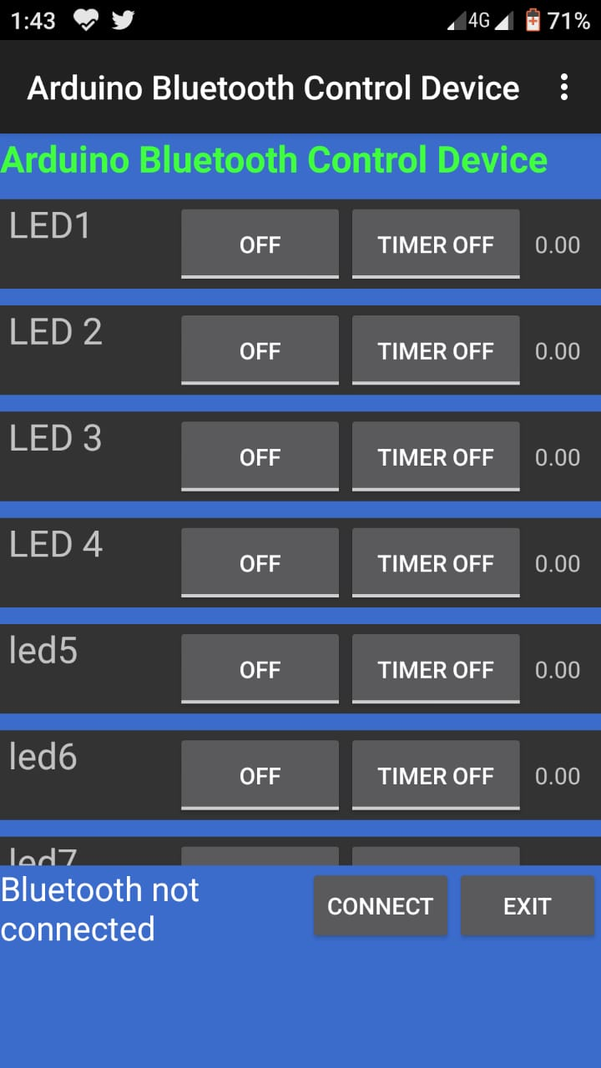

Figure 17: Home Screen

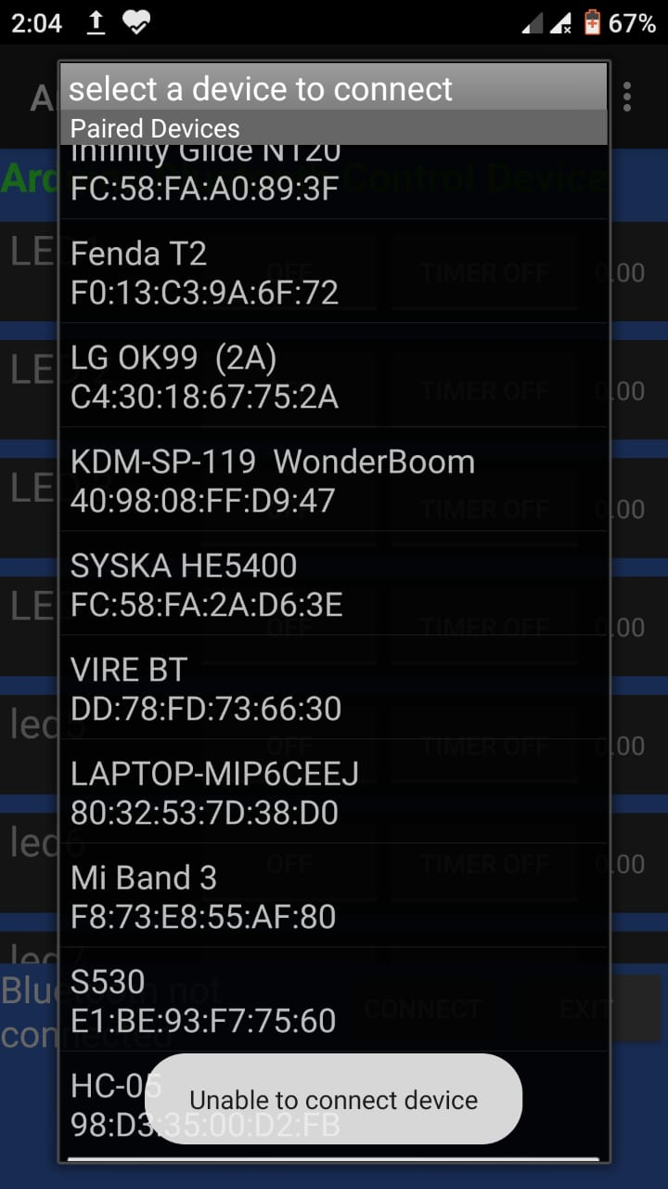

**Figure 18: Connecting Device**



Figure 19: Device connected & signal strength

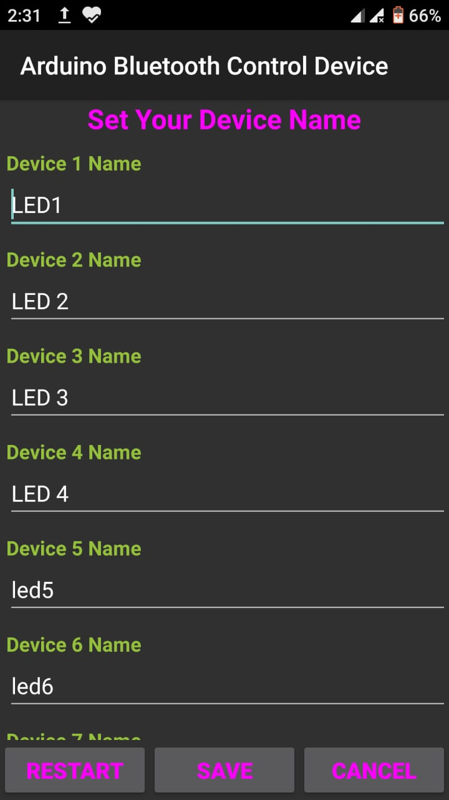

**Figure 20: Set device name**

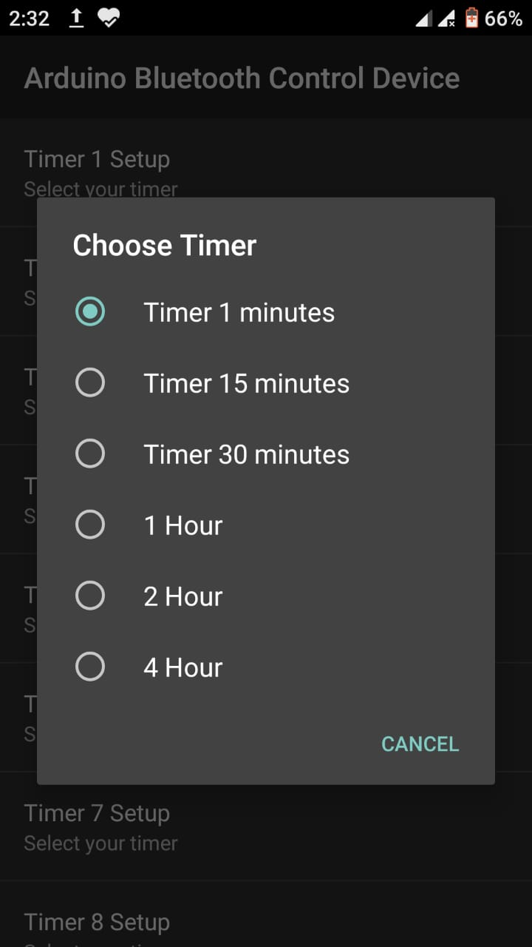

**TIMER SET UP**



Figure 21: Devices control switches icons

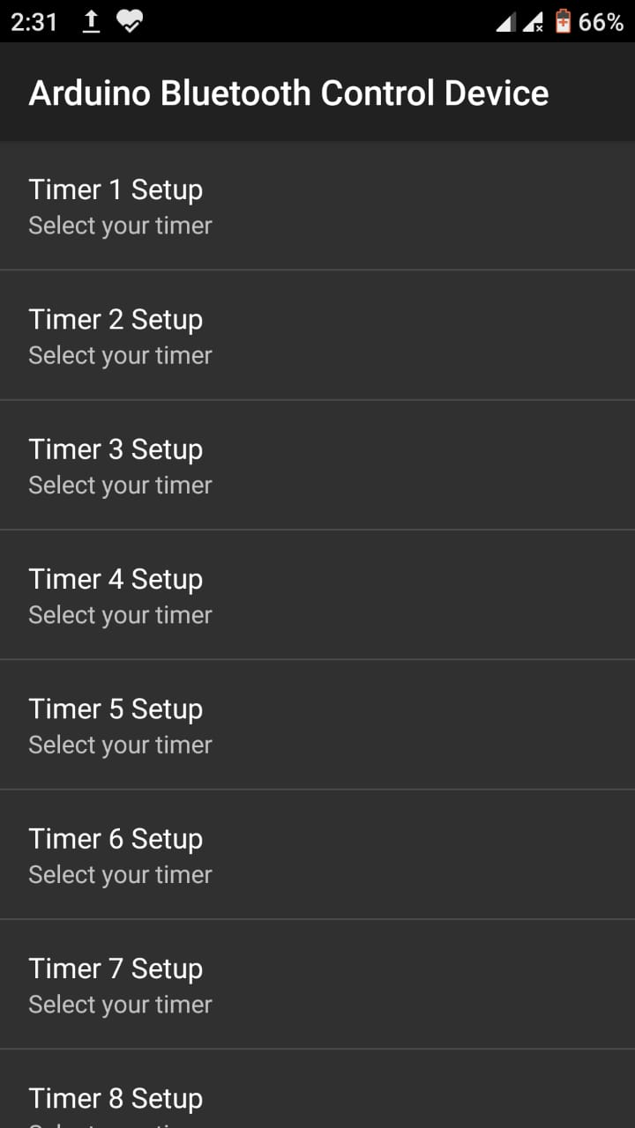

**Figure 22: Devices control switches Off BY TIME**

# Chapter4

**Serial communication in 89s52**



### Chapter4

**Serial communication in 89s52**

**SERIAL COMMUNICATION-INTRODUCTION:** Serial is a device communication protocol that is standard on almost every PC. Do not confuse it with universal serial bus (USB). Most computers include two EIA-232 based serial ports. Serial is also a common

communication protocol for instrumentation in many devices, and numerous GPIB- compatible devices come with an EIA-232 port. Furthermore, you can use serial communication for data acquisition in conjunction with a remote sampling device

### Selection of baud rate:-

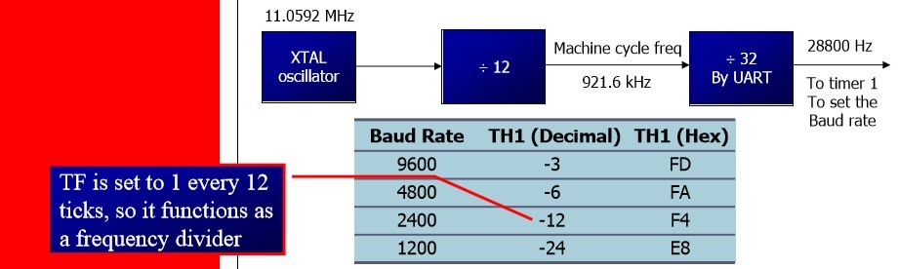

Figure 27: Selection of baud rate

* 1. **SBUF register:-**

SBUF is an 8-bit register used for serial communication.

For a byte data to be transferred via the Txd line, it must be placed in the SBUF register. The moment a byte is written into SBUF, it is framed with the start and stop bits and transferred serially via the Txd line

SBUF holds the byte of data when it is received by 8051 RxD line .When the bits are received serially via RxD, the 8051 de frames it by eliminating the stop and start bits, making a byte out of the data received, and then placing it in SBUF.

* + 1. **Configuration of SCON register:** -SCON is an 8-bit register used to program the start bit, stop bit, and data bits of data framing, among other things

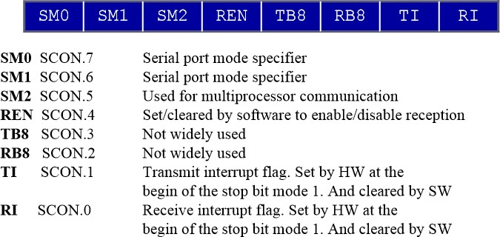

Fig. 28.SCON register

* + 1. **SM0, SM1**

They determine the framing of data by specifying the number of bits per character, and the start and stop bits.

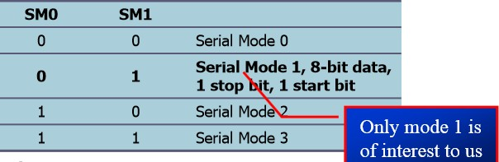

Figure 29: Serial mode selection

* 1. **REN (receive enable):-**

It is a bit-addressable register. When it is high, it allows 8051 to receive data on RxD pin .If low, the receiver is disable.

* 1. **TI (transmit interrupt) :-**When 8051 finishes the transfer of 8-bit character .It raises TI flag to indicate that it is ready to transfer another byte .TI bit is raised at the beginning of the stop bit.
  2. **RI (receive interrupt) :-**When 8051 receives data serially via RxD, it gets rid of the start and stop bits and places the byte in SBUF register .It raises the RI flag bit to indicate that a byte has been received and should be picked up before it is lost .RI is raised halfway through the stop bit.

#### Steps for transmitting and receiving of character

* + 1. **The steps that 8051 goes through in transmitting a character via TxD**
       1. The byte character to be transmitted is written into the SBUF register
       2. The start bit is transferred
       3. The 8-bit character is transferred on bit at a time
       4. The stop bit is transferred .It is during the transfer of the stop bit that 8051 raises the TI flag, indicating that the last character was transmitted
       5. By monitoring the TI flag, we make sure that we are not overloading the SBUF .If we write another byte into the SBUF before TI is raised; the un-transmitted portion of the previous byte will be lost
       6. After SBUF is loaded with a new byte, the TI flag bit must be forced to 0 by CLR TI in order for this new byte to be transferred.

By checking the TI flag bit, we know whether or not the 8051 is ready to transfer another byte .It must be noted that TI flag bit is raised by 8051 itself when it finishes data transfer ¾It must be cleared by the programmer with instruction CLR TI ¾If we write a byte into SBUF before the TI flag bit is raised, we risk the loss of a portion of the byte being transferred .The TI bit can be checked by ¾The instruction JNB TI, xx .Using an interrupt.

#### Programming the 8051 to transfer character bytes serially

* + - 1. TMOD register is loaded with the value 20H, indicating the use of timer 1 in mode 2 (8-bit auto-reload) to set baud rate
      2. The TH1 is loaded with one of the values to set baud rate for serial data transfer
      3. The SCON register is loaded with the value 50H, indicating serial mode 1, where an 8- bit data is framed with start and stop bits
      4. TR1 is set to 1 to start timer 1
      5. TI is cleared by CLR TI instruction
      6. The character byte to be transferred serially is written into SBUF register
      7. The TI flag bit is monitored with the use of instruction JNB TI, xx to see if the character has been transferred completely
      8. To transfer the next byte, go to step 5
      9. The steps that 8051 goes through in transmitting a character via Txd
      10. The byte character to be transmitted is written into the SBUF register
      11. The start bit is transferred
      12. The 8-bit character is transferred on bit at a time
      13. The stop bit is transferred .It is during the transfer of the stop bit that 8051 raises the TI flag, indicating that the last character was transmitted
      14. By monitoring the TI flag, we make sure that we are not overloading the SBUF .If we write another byte into the SBUF before TI is raised, the transmitted portion of the previous byte will be lost
      15. After SBUF is loaded with a new byte, the TI flag bit must be forced to 0 by CLR TI in order for this new byte to be transferred

#### Importance of TI Flag

By checking the TI flag bit, we know whether or not the 8051 is ready to transfer another byte It must be noted that TI flag bit is raised by 8051 itself when it finishes data transfer .It must be cleared by the programmer with instruction CLR TI ¾If we write a byte into SBUF before the TI flag bit is raised, we risk the loss of a portion of the byte being transferred .he TI bit can be checked by The instruction JNB TI, xx .Using an interrupt

#### Programming the 8051 to receive character bytes serially

* + - 1. TMOD register is loaded with the value 20H, indicating the use of timer 1 in mode 2 (8-bit auto-reload) to set baud rate
      2. TH1 is loaded to set baud rate
      3. The SCON register is loaded with the value 50H, indicating serial mode 1, where an 8- bit data is framed with start and stop bits
      4. TR1 is set to 1 to start timer 1
      5. RI is cleared by CLR Reinstruction
      6. The RI flag bit is monitored with the use of instruction JNB RI, xxto see if an entire character has been received yet
      7. When RI is raised, SBUF has the byte, its contents are moved into a safe place
      8. To receive the next character, go to step 5

# Chapter 5 Program

### Chapter 5 Program

### PROGRAM CODES:

##### #include <reg52.h>

int lamp1 = 2;

int lamp2 = 3;

int lamp3 = 4;

int music = 5;

int pc = 6;

int mobile = 7;

int fan = 8;

int socket = 9;

int Received = 0;

int lamp1_state = 0;

int lamp2_state = 0;

int lamp3_state = 0;

int music_state = 0;

int pc_state = 0;

int mobile_state = 0;

int fan_state = 0;

int socket_state = 0;

void setup() {

Serial.begin(38400);

pinMode(lamp1, OUTPUT);

pinMode(lamp2, OUTPUT);

pinMode(lamp3, OUTPUT);

pinMode(music, OUTPUT);

pinMode(pc, OUTPUT);

pinMode(mobile, OUTPUT);

pinMode(fan, OUTPUT);

pinMode(socket, OUTPUT);

}

void loop() {

if (Serial.available() > 0)

{

Received = Serial.read();

}

if (lamp1_state == 0 && Received == '1')

{

digitalWrite(lamp1, HIGH);

lamp1_state = 1;

Received = 0;

}

if (lamp1_state == 1 && Received == '1')

{

digitalWrite(lamp1, LOW);

lamp1_state = 0;

Received = 0;

}

if (lamp2_state == 0 && Received == '2')

{

digitalWrite(lamp2, HIGH);

lamp2_state = 1;

Received = 0;

}

if (lamp2_state == 1 && Received == '2')

{

digitalWrite(lamp2, LOW);

lamp2_state = 0;

Received = 0;

}

if (lamp3_state == 0 && Received == '3')

{

digitalWrite(lamp3, HIGH);

lamp3_state = 1;

Received = 0;

}

if (lamp3_state == 1 && Received == '3')

{

digitalWrite(lamp3, LOW);

lamp3_state = 0;

Received = 0;

}

if (music_state == 0 && Received == '4')

{

digitalWrite(music, HIGH);

music_state = 1;

Received = 0;

}

if (music_state == 1 && Received == '4')

{

digitalWrite(music, LOW);

music_state = 0;

Received = 0;

}

if (pc_state == 0 && Received == '5')

{

digitalWrite(pc, HIGH);

pc_state = 1;

Received = 0;

}

if (pc_state == 1 && Received == '5')

{

digitalWrite(pc, LOW);

pc_state = 0;

Received = 0;

}

if (mobile_state == 0 && Received == '6')

{

digitalWrite(mobile, HIGH);

mobile_state = 1;

Received = 0;

}

if (mobile_state == 1 && Received == '6')

{

digitalWrite(mobile, LOW);

mobile_state = 0;

Received = 0;

}

if (fan_state == 0 && Received == '7')

{

digitalWrite(fan, HIGH);

fan_state = 1;

Received = 0;

}

if (fan_state == 1 && Received == '7')

{

digitalWrite(fan, LOW);

fan_state = 0;

Received = 0;

}

if (socket_state == 0 && Received == '8')

{

digitalWrite(socket, HIGH);

socket_state = 1;

Received = 0;

}

if (socket_state == 1 && Received == '8')

{

digitalWrite(socket, LOW);

socket_state = 0;

Received = 0;

}

}

### Program detail

* + 1. #include <reg52.h>:-By using this we define the header file of micro –controller 89s52.
    2. #define OUT_PORT2 P1:-this line is used for defining a port with output port.
    3. SBUF is an 8-bit register used solely for serial communication ¾For a byte data to be transferred via the Txd line, it must be placed in the SBUF register .The moment a byte is written into SBUF, it is framed with the start and stop bits and transferred serially via the Txd line .SBUF holds the byte of data when it is received by 8051 RxD line .When the bits are received serially via RxD, the 8051 deframes it by eliminating the stop and start bits, making a byte out of the data received, and then placing it in SBUF.
    4. SCON is an 8-bit register used to program the start bit, stop bit, and data bits of data framing, among other things.
    5. TI (transmit interrupt) When 8051 finishes the transfer of 8-bit character .It raises TI flag to indicate that it is ready to transfer another byte TI bit is raised at the beginning of the stop bit.
    6. RI (receive interrupt) When 8051 receives data serially via RxD, it gets rid of the start and stop bits and places the byte in SBUF register It raises the RI flag bit to indicate that a byte has been received and should be picked up before it is lost .RI is raised halfway through the stop bit.

# Chapter 6 Circuit diagram

**&**

**Component List**

### Chapter 6

**Circuit diagram & Component List**

* 1. **Component list:-**

|  |  |  |
| --- | --- | --- |
| **S.No** | **Component Name** | **Nos. Required** |
| 1 | HC-05 Bluetooth module | 1 |
| 2 | ARDUINO UNO micro controller IC | 1 |
| 3 | ULN2003 IC | 3 |
| 4 | 5V relay | 2 |
| 5 | Crystal 12MHz or 11.0592MHz | 1 |
| 6 | 1K Resistor | 1 |
| 7 | 22µf or 10µf electrolyte capacitor | 2 |
| 8 | 30pf or 22pf ceramic capacitor | 2 |
| 9 | 10k resistor network | 3 |
| 10 | 7805 IC | 2 |
| 11 | 9V battery | 2 |
| 12 | 220v to 6v-0-6v step down transformer | 1 |
| 13 | 1N4007 diode | 3 |

### Circuit Diagram:

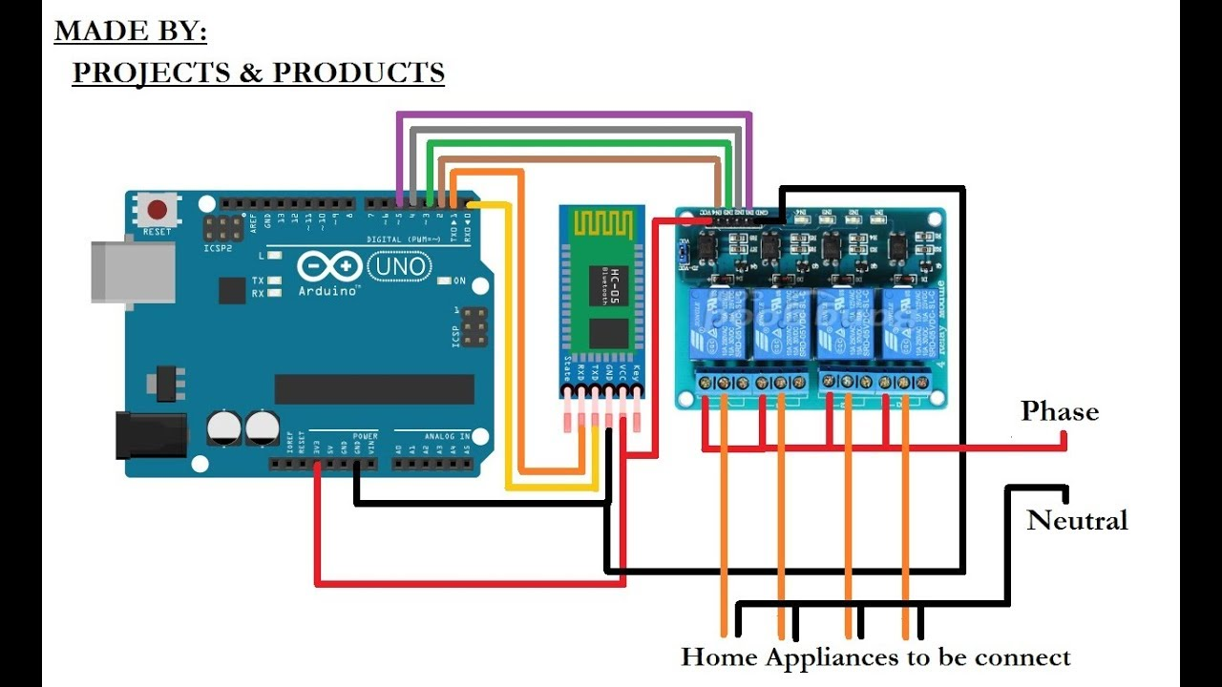

# Chapter 7

**Problem description**



### Chapter 7

### Problem description

##### The various problems & FAQ’s associated with the project are:

* 1. No manual control to switch on and off or in system when failed:-

In that case we can use a two way switch so if automation system fails than control given to manual. As the manual control provided unskilled user can perform his routine control. As shown below.

In fig a two way connection with relay is shown. The control act as a XOR operation mines that output is one when both input are same. So output is available when positions of both switches are same.

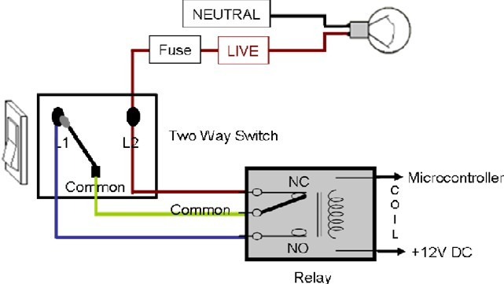

Fig. 29.Wiring connection to switch

* 1. **No confirmation of change of output:-**

To overcome this problem programming can be do so that controller can compare its previous state. So if state of switch not changes than controller send an error comes or no change.

* 1. No debugging option:-

This can be a very good feature of project i.e. you can check that where problem comes at hardware or in software. So controller gave all information about communication.

* 1. Complex user interface:-

User interface must be simple so no need to teach the other every time. But in similar project interface is complex.

* 1. Different key to on and off:-

In survey it is seen that there are two different key to turn n and off appliances. But if in programming toggle of bit is done then more automation can be done in this project.

* 1. Restart power at every new pairing of device:-

In HV-05 Bluetooth module if a device is parried then this configuration is save. So at every new device pairing needs restart of circuit power. This problem can be removed if we use a feature of HC-05 Bluetooth i.e. “key” this a pin in Bluetooth that can remove all paired detail when this pin high pulses. So connection of this pin with micro controller can rest the pairing.

* 1. Large change in house wiring:-

In similar project the automation done by mobile only so all connection needs to change in wiring and removal of button connection is needed .So to avoid this circuit is so design as sown in problem 1 solution.

* 1. **Security of hacking control:-**

The Bluetooth connection kept open so other con connect and take control. so the master user must connect to Bluetooth and removal of pair info must by master controller by software control.

# Chapter 8 Advantages &

**Disadvantages**



### Chapter 8 Advantages & Disadvantages

* 1. **Advantages**

#### Wireless control:-

By using this project wireless control can be within the hands of user.

#### Monitoring:-

This circuit allow monitoring of all appliance within range of communication with Bluetooth.

#### Status checking :-

When user doesn’t know appliances is on off then user can only check the status only.

#### Confirmation of changing switch state:-

When switch is press ten two status will be shown on mobile phone i.e. old status and new status

#### Manual control:-

Manual control is given so an unskilled user can be change the current status.

### 8.2. Disadvantages:-

#### Bluetooth range:-

It is good to use Bluetooth for automation but automation is kept within a range 0f 10-30 metres. So control can be achieved from outside range.

#### Connection:-

Application must be connected after disconnection from Bluetooth.

#### configuration of application software:-

If new user want to connect then first download application software and then code must be enter and more configuration must be done.

# Chapter 9

**FUTURE SCOPE**



### Chapter 9 FUTURE SCOPE

This project can be further developed by integrating it with the internet to monitor your home while sitting in a remote area. By doing this, one can keep an eye on his or her home through an internet connected to the user’s mobile phone or PC or laptop. This will not only improve the security of your home in this modern day world but will also assist in conservation of energy like if you left any home appliance switched on by mistake, then you can check the status of the appliance on the graphical interface made on your mobile and can switch it off using the internet connectivity.

# CONCLUSION

**&**

**REFERENCES**



### CONCLUSION

In conclusion, this low cost system is designed to improve the standard living in home. The remote control function by smart phone provides help and assistance especially to disabled and elderly. In order to provide safety protection to the user, a low voltage activating switches is replaced current electrical switches. Moreover, implementation of wireless Bluetooth connection in control board allows the system install in more simple way. The control board is directly installed beside the electrical switches whereby the switching connection is controlled by relay.

Furthermore, flexible types of connections are designed as backup connections to the system. The connected GUIs are synchronized to the control board. They indicate the real- time switches status. The system is designed in user-friendly interface. The easy to use interface on Window and Android GUI provides simple control by the elderly and disabled people.

For future work, the Window GUI will be implemented with speech recognition voice control. The android GUI will be implemented as a remote Bluetooth microphone to the Window GUI. All the voice signal inputs to the smart phone will be transmitted to the Window GUI for signal processing. Also, the push buttons implemented in low voltage activating switches will be replaced by capacitive sensing switches. All the future work is expected without spend extra cost, even one cent from the current system.

### REFERENCES

* Earthpower.in